**Issue Brief: BenchMarking the Results of ACM and DOL-IMPAQ Paid Leave Microsimulation Models**

To assist researchers and policymakers in simulating leave usage and benefit costs under alternative paid leave policy scenarios, the US Department of Labor (DOL) contracted IMPAQ and Institute for Women’s Policy Research (IWPR) to revise and update a paid leave microsimulation model created by IWPR, Randy Albelda, and Alan Clayton-Matthews (the ACM model). Under this contract, IMPAQ has implemented several updates to the ACM model. To increase transparency and to promote wider use, IMPAQ has recast the ACM model as an open-source model with an intuitive front-end in addition to features that enable user to choose the preferred estimation methods for model estimation. We refer to this new model as the 2020 DOL- IMPAQ model.

In this brief, we test performance of the IMPAQ model against the ACM and also compare both the models to real-world benchmarks using data from existing state paid programs in California, Rhode Island, and New Jersey. The results show that the final estimates on leave usage and benefit costs from the IMPAQ model are similar to the ACM model’s results. The advantages offered by the IMPAQ model over the ACM model are several new features to enable comparisons across existing programs and to test multiple different leave policy scenarios simultaneously. In addition, the IMPAQ model also typically has a significantly shorter runtime than the ACM model.

# 1. Background and Project Overview

Access to and use of leave is critical to an individual’s financial security and quality of life (Winston, 2017). Nearly every other developed country provides paid maternity leave, and most advanced industrial countries offer extended paid medical and parental leaves. The United States is an outlier. There is no federal requirement for paid leave or sick days. Consequently, many individuals, especially low-income workers, face difficult tradeoffs. In 2016, only 14 percent of US workers has access to paid family leave through their employers, and 68 percent had paid sick leave (Bureau of Labor Statistics, 2016).

However, in recent years, paid family and medical leave programs have received considerable bipartisan support, with some states and municipalities already introducing paid family leave programs. California enacted paid family leave legislation in 2002, New Jersey in 2008, Rhode Island in 2013, New York in 2016 (effective January 2018), District of Columbia in 2017 (effective July 2020), Washington in 2017 (effective January 2020), Massachusetts in 2018 (effective in 2021), Oregon in 2019 (effective in 2023), Connecticut in 2019 (effective in 2022), and Maine in 2019 (effective in 2021).

Several states and municipalities have examined the feasibility of instituting paid leave polices. However, the sophistication and reliability of the methods used to conduct the required analyses are inconsistent. In [year], Randy Albelda and Alan Clayton-Matthews built the ACM microsimulation model in partnership with IWPR to support different state’s quantitative evaluation of proposed paid leave policy. The ACM model offered a rigorous way for states and municipalities to test different paid-leave program scenarios and to estimate the implications on costs in benefits paid out. However, the proprietary program was built in multiple programming languagesthat requires both proprietary approval and advanced programming skills to understand and use. To make the model more accessible to a wider audience, DOL contracted with IMPAQ International and IWPR to create a new version of the model (the IMPAQ model) usingopen-source programming languages. IMPAQ has made several improvements to the model output structure, and designed an accessible and easy-to-use graphical user interface. Also included in the IMPAQ model are several alternative simulation and estimation techniques, compared with the ACM model’s sole option of imputation via logit regression.

In this brief, we benchmark both the ACM and the IMPAQ models against actual statistics reported by three states with appreciable historical leave program data – California, New Jersey, and Rhode Island. Corresponding with the timeframe of the 2012-2016 ACS 5-year survey data set used in the simulation models, we compare the 5-year averages of California and New Jersey from 2012-2016. Rhode Island’s *Temporary Caregiver Insurance* (paid family leave added to the United States’ first medical coverage under a temporary disability insurance system) was enacted in 2014, so averages from 2014-2016 years are used for Rhode Island.

# 2. Methodology

The simulation model proceeds in six broad steps as shown in Exhibit 1. First, the input data sets are individually cleaned and prepared for use in the model. Second, FMLA survey data is used to calibrate the leave taking estimation model for application in ACS data. Third, leave taking behavior is imputed on an ACS data set using the estimation model. The ACS data is selected based on the user-defined geography of interest; be it national-level leave taking, or leave taking for a specific state. Fourth, participation and benefits received are calculated in the ACS using user-specified leave program characteristics and behavioral assumptions. Fifth, if the user has elected to calculate what tax structure will be required to pay for the program, the benefit financing module calculations are run. Finally, the model displays simulation results and financing estimates in tabular and graphical form. More detailed technical documentation of the model is available on request.

Exhibit 1: Steps of the Model

6. Output simulation results and estimates

3. Impute leave taking for ACS data

4. Adjust ACS data based on the characteristics of the simulated leave program

1. Clean Census & FMLA input data sets

2. Calibrate leave taking estimation model from FMLA data

5. Apply benefit financing module calculations

We perform two different types of comparisons:

1. ***Comparing simulated and published program costs.*** Predicting total program cost in benefit outlays is one of the primary uses of the models. For each of the three states under consideration (California, New Jersey, Rhode Island), we specified the model parameters to approximate the eligibility rules and benefit payout schedules of the actual programs. After simulation of each individual’s eligibility and leave taking, we compute the population weighted sum of benefits received by each ACS worker to represent total program cost, which we compare with the published program outlays of the same state.
2. ***Comparing simulated and observed population-level statistics.*** Simulated total program cost is constructed from a series of intermediary simulated variables. The robustness of a microsimulation model therefore cannot be fully verified solely by considering program cost. In addition, we need to validate the model’s ability to approximate the real-world mechanisms that determine by examining a series of key intermediate outputs. We consider the following intermediate outputs at the population level:

* Total number of workers eligible for the program
* Total number of leave takers receiving benefits
* Average lengths of program-paid leaves

Both models were run with parameters selected to mirror each state’s program rules; rules were drawn from a DC paid leave economic impact report (DC Council, 2016). Other than state-specific rules adjustment, default ACM model parameters were used. The selected parameters for each state are included in an appendix. Full documentation of the model and its parameters are available on request. For testing purposes, numbers generated in this memo are from the R version of the IMPAQ model (both R and Python versions of the model were constructed).

Some of these analyses are categorized by the six major leave types: (1) own sickness leave, (2) maternal disability, (3) new child bonding, (4) care for an ill spouse, (5) care for an ill parent, and (6) care for an ill child. In all three states, the first two leave types are paid by the state temporary disability insurance program. The latter four types are paid by the state paid family leave program.

# 3. IMPAQ Model versus Actual Data Results

This section discusses the IMPAQ simulation results with respect to the historical data from actual programs in California, New Jersey, and Rhode Island. All model statistics are reported with the sampling standard error derived from the ACS replicate weights procedure described by the Census Bureau (Census Bureau, 2014). Standard error of actual values in all cases is zero.

## 3.1 Total Program Benefit Outlays

Exhibit 2 compares each model’s simulated annual benefit outlays with actual annual average state reported outlays between 2012 and 2016, which were obtained from reports published on their respective state websites.[1] For New Jersey and Rhode Island, both models’ estimates came within the sampling margin of error of the actual benefit outlays. For California, the IMPAQ model understated actual benefits by about 9 percent while the ACM model underestimated actual benefits by about 6 percent.

**Exhibit 2. Simulated vs. Actual Benefits Outlaid**

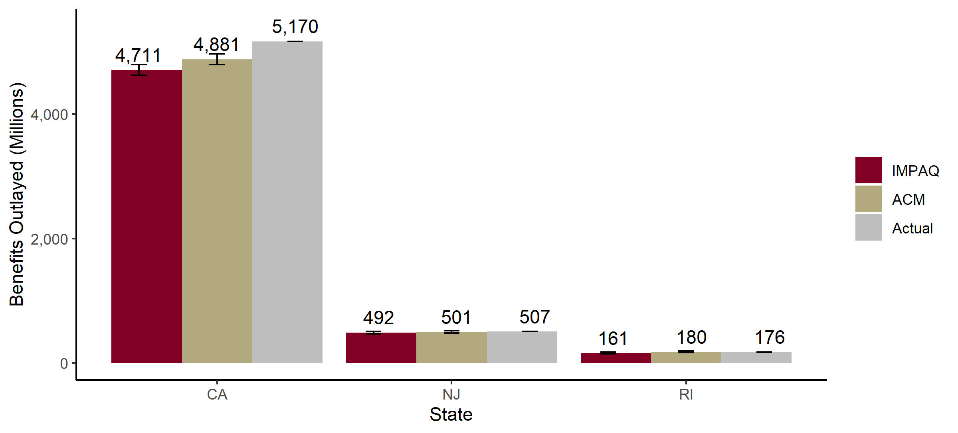

## 3.2 Total Number of Eligible Workers

Exhibit 3 compares the number of eligible workers for each state’s leave program. This quantity does not require any simulation. Eligibility is determined solely through original ACS variables for class of employment and earnings (the main criteria for eligibility in these three programs), which means that both ACM and IMPAQ models have identical estimates for eligible workers.

Each model underestimated the number of eligible workers in California – 15 million versus 17.3 million workers. The ACS indicated approximately 17.1 million individuals working in California. Based on our analysis of the California ACS, approximately 1.5 million workers were excluded due to failure to meet earnings requirements and .5 million were excluded due to self-employment. The earnings requirements are subject to some error because California’s earnings requirement are based on quarterly earnings whereas earnings are only observed in annual aggregates within the ACS. Individuals with volatile quarterly earnings may be incorrectly excluded by the simulation logic as a result. To disambiguate discrepancies in ACS estimation of eligible workforce with model simulation accuracy, the take up rates for both models have been adjusted to account for this difference. As a result, discrepancies in all other exhibits are not attributable to differences in eligible workers between ACS estimates and real-world numbers.

The models closely simulate the actual number of New Jersey and Rhode Island eligible workers. In the case of New Jersey, there is some nuance to eligibility across leave types. The displayed number is for eligibility for Medical Leave coverage (maternal disability and own illness leaves), which has fewer eligible workers due to an opt-out option for employers with private insurance. Eligibility for Family Leave (ill relative and child bonding) is 30 percent higher at 3.83 million. Both models employ leave-type specific parameters to adjust for differing levels of eligibility among leave types.

**Exhibit 3. Simulated vs. Actual Eligible Workers**

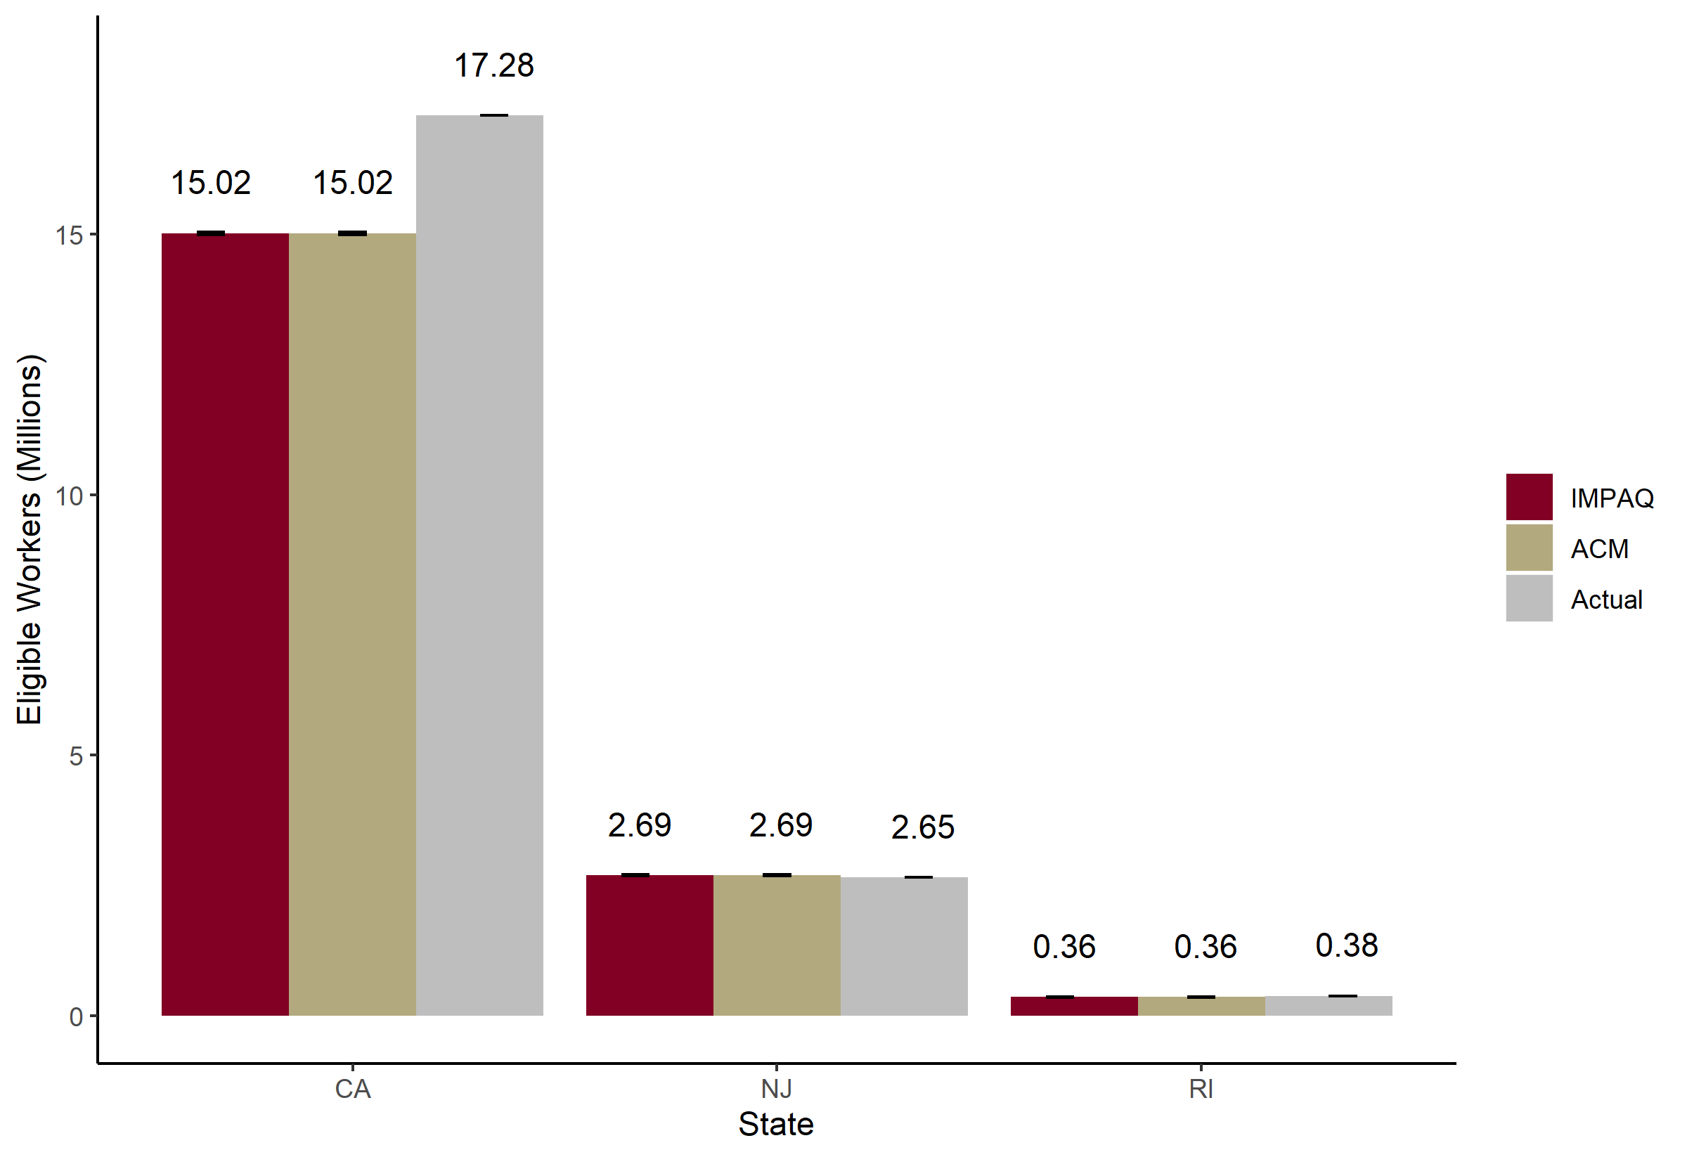Note: Actual numbers are estimated 2015 eligible population (DC Council, 2016).

## 3.3 Total Number of Leave Takers

This section discusses the total number of individuals that take leave and claim benefits for each leave type. Exhibit 4 presents the results for California for each of the six leave types. The IMPAQ model slightly overestimates the overall number of participants (1.26 million participants simulated versus 1.11 million actual). Despite this, the IMPAQ model slightly underestimates the total benefits outlaid, as shown in Exhibit 2. While we cannot directly observe actual leave lengths in California, one possible explanation for this is the IMPAQ model is underestimating the length of leave individuals are claiming benefits for; consistent with what we see in Exhibit 7 for leave length estimation in New Jersey. Another possibility may be the ACS earnings distribution is more skewed toward lower wage workers than in actuality, causing the model to underestimate the weekly benefit outlay to some workers. The ACM model gets a slightly closer estimate in California benefits outlaid than the IMPAQ model, but still slightly understates benefits despite slightly overstating leave taker participation.

**Exhibit 4 Simulated vs. Actual Participating Leave Takers in California**

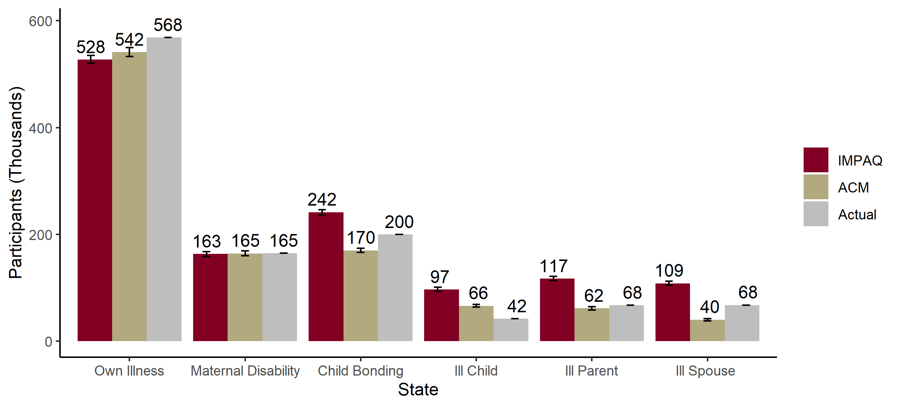

Exhibit 5 shows participant numbers in New Jersey. The model closely approximates New Jersey in both overall participation (about 133,000 participants simulated compared to 124,000 actual participants), and the distribution of leave types across the participant population. Again, there is a slight overstatement of leave taking by the IMPAQ model, especially maternal disability.

**Exhibit 5. Simulated vs. Actual Participating Leave Takers in New Jersey**

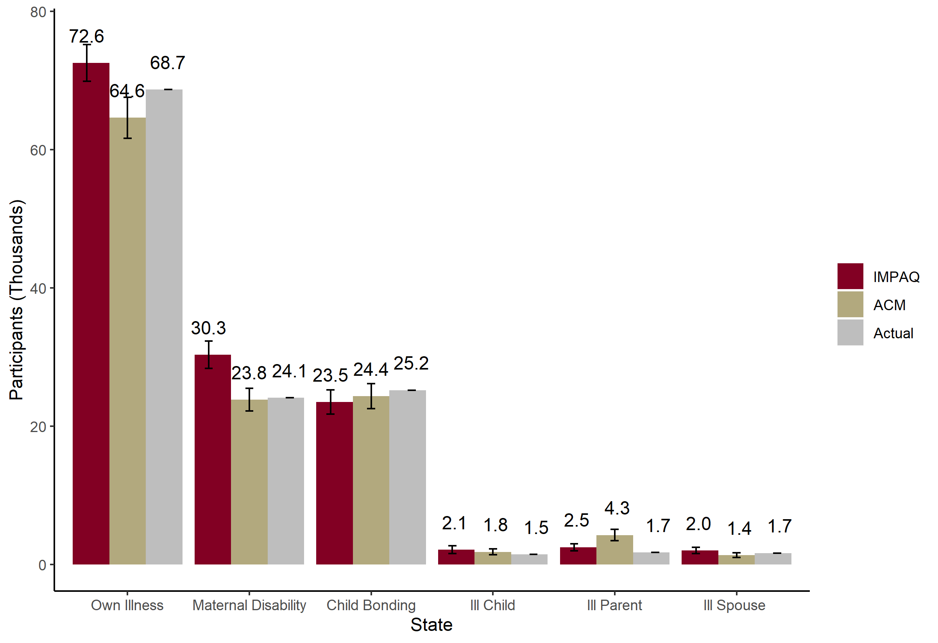

Exhibit 6 shows the participation results for Rhode Island. The model slightly understates the number of participants, estimating about 39,700 participants compared to 44,900 participants in the actual program. By leave type, the model simulated similar numbers except for own illness and child bonding leaves. The underestimations in these two leave types explain the overall difference in leave program participation. This is a likely explanation for why the IMPAQ model understated the overall benefit outlays for the Rhode Island program. Despite this, the IMPAQ model still slightly overestimates maternal disability leave taking. The ACM model had less of an underestimate for own illness and a slight overestimate for child bonding, which is a plausible reason for why the ACM model more closely approximated the actual Rhode Island benefits outlaid.

**Exhibit 6. Simulated vs. Actual Participating Leave Takers in Rhode Island**

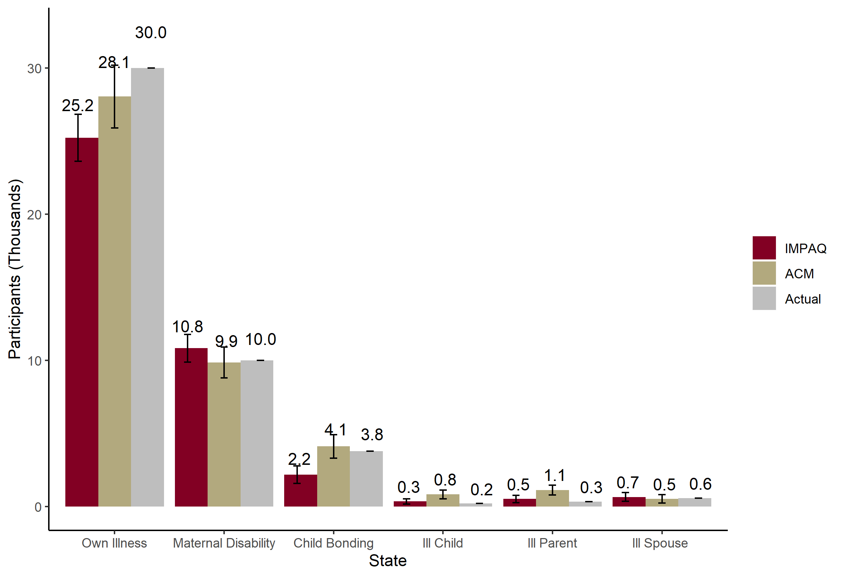

## 3.4 Average Leave Length

Of the three states, only New Jersey reported weeks of participation in sufficient detail. Exhibit 7 shows the simulated versus actual mean leave lengths in New Jersey. Both models simulated substantially shorter lengths for all leave types. However, the actual New Jersey data may not be directly comparable to the simulated quantities. For example, although state regulations only permit up to 6 weeks of paid ill parent leave, the data contains leaves of 7 weeks, which suggests that New Jersey may record leave length statistics in a different way to that reported in the models. One possibility is that New Jersey is double counting leave types (i.e. an individual who takes leave for both ill parent and own health leave has their leave counted for both leave types, which the models do not allow for). Another possibility is that New Jersey is aggregating unpaid and paid weeks. Whether this fully accounts for the models large underestimates is unknown without New Jersey publishing more information on how their leave lengths are derived. Nevertheless, it is a curious result given how close the actual benefits and participant estimates were by both models. Another possibility could be the leave length extension effect in the presence of the program has a greater effect than simulated.

**Exhibit 7. New Jersey Simulated vs. Actual Mean Participation Length (in Weeks)**

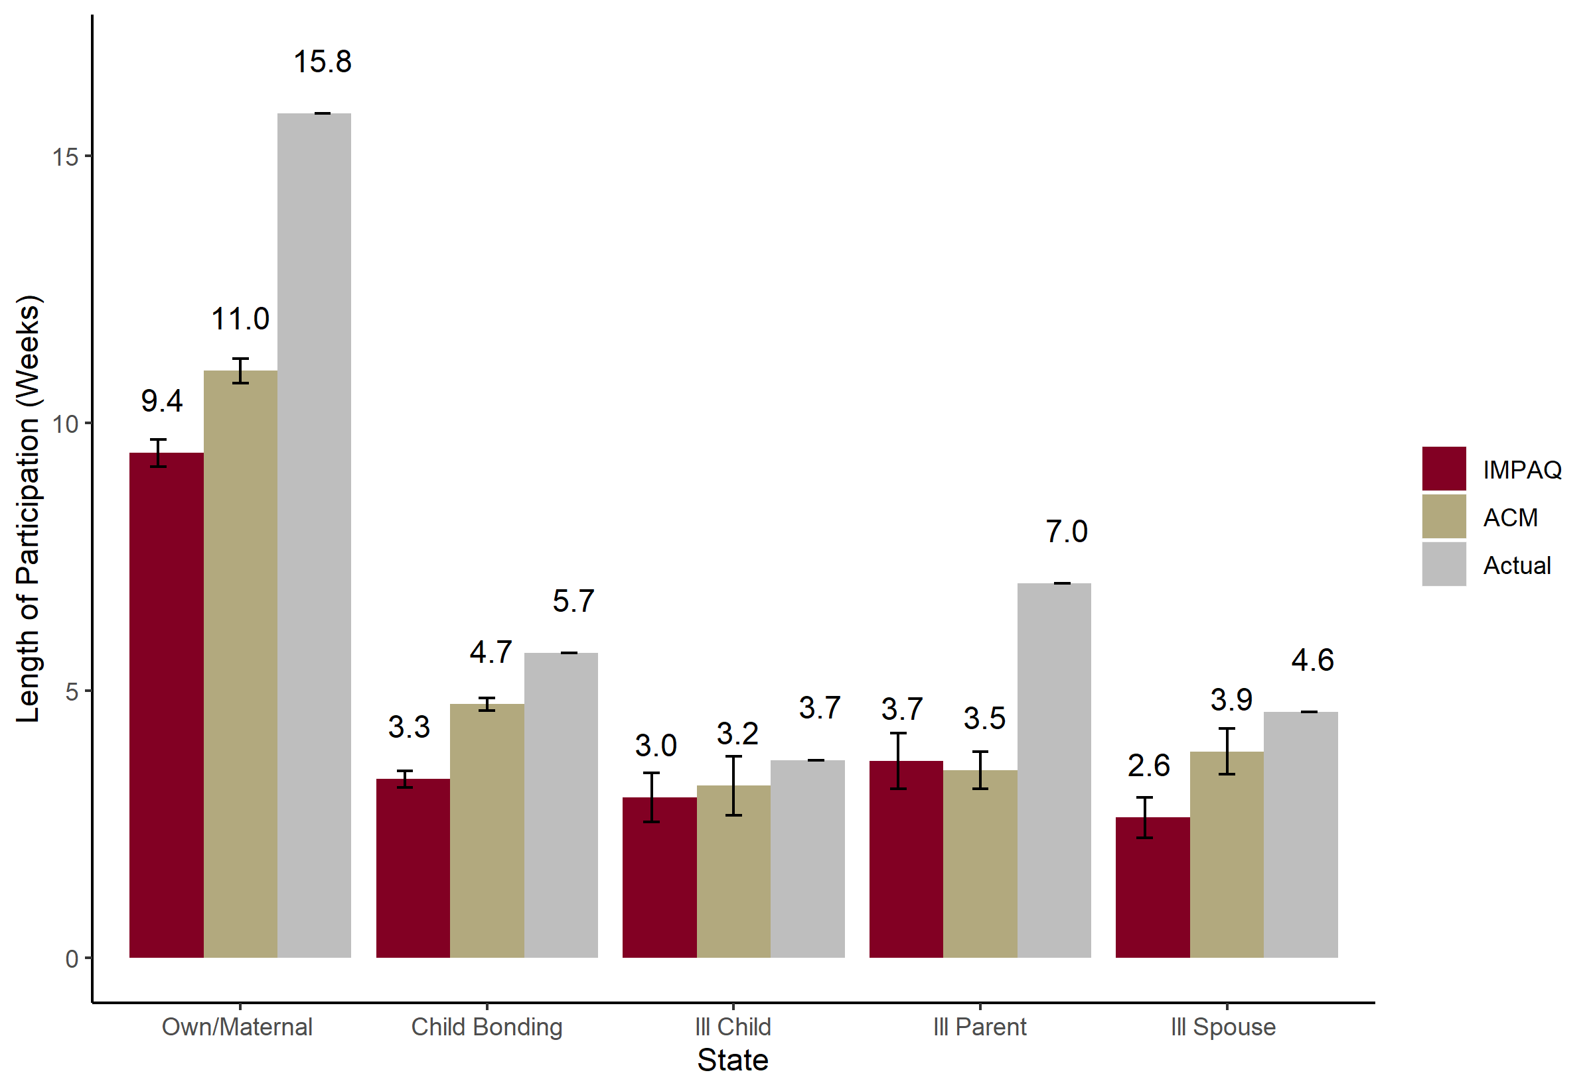

Note: Actual leave length statistics not available for California and Rhode Island

# 5. Conclusion

The IMPAQ model replicates the real-world state leave programs and participation statistics well, and produces results comparable to the original ACM model. There are, however, some model-specific peculiarities that slightly overestimate maternal disability leave taking in two of the three states, whereas the ACM model does not. Both models deviated slightly from actual statistics at times. In New Jersey, both models underestimated participation lengths (though there is reason to doubt the comparison data is appropriate in this instance).

It is important to note that the IMPAQ model can produce different estimates than those presented here. The estimates in this issue brief result from a “conservative” parameter specification designed simply to match leave program rules and default values set by the original ACM model. These baseline values can be calibrated further to more closely match leave actual statistics. We refrained from excessive calibration and deviations from default parameters so as to best illustrate typical model performance.

# Bibliography

Bureau of Labor Statistics (2016). Table 32. Leave benefits: Access, Civilian Workers, National Compensation Survey, March 2016. Retrieved from https://www.bls.gov/ncs/ebs/benefits/2016/ownership/civilian/table32a.htm.

Census Bureau (2014). American Community Survey Design and Methodology. Chapter 12: Variance Estimation. Retrieved from <https://www2.census.gov/programs-surveys/acs/methodology/design_and_methodology/acs_design_methodology_report_2014.pdf>

Clayton-Matthews, Alan, and Randy Albelda (2017). "Description of the Albelda Clayton-Matthews/IWPR 2017 Paid Family and Medical Leave Simulator Model."

# Office of the Budget Director, Council of the District of Columbia (2016). Economic and Policy Impact Statement: Universal Paid Leave Amendment Act of 2016. (B21-415). Retrieved from <http://lims.dccouncil.us/Download/34613/B21-0415-Economic-and-Policy-Impact-Statement-UPLAA3.pdf>

Winston, P. (2017). Exploring the Relationship between Paid Family Leave and the Well-being of Low-Income Families: Lessons from California. Washington, DC: U.S. Department of Health and Human Services, Office of the Assistant Secretary for Planning and Evaluation, Office of Human Services Policy.

# Appendix

**ACM Model Parameters Used**

| Parameter | California | New Jersey | Rhode Island |
| --- | --- | --- | --- |
| DEPENDENTALLOWANCE | 10 | 10 | 10 |
| ELIGIBILITYRULES | a_earnings=300 | a_earnings=8400 | a_earnings=3840 |
| EXTENDLEAVES | Yes | Yes | Yes |
| GOVERNMENT | Yes | No | No |
| MAXWEEKS | OH=52, MD=52, NC=6, IC=6, IS=6, IP=6 | OH=26, MD=26, NC=6, IC=6, IS=6, IP=6 | OH=30, MD=30, NC=4, IC=4, IS=4, IP=4 |
| extendproportion | OH = 0.7 MD = 1.0 NC = 0.7 IC = .25 IS = .25 IP = .25; | OH = 0.7 MD = 1.0 NC = 0.7 IC = .25 IS = .5 IP = .5; | OH = 0.7 MD = .7 NC = 0.7 IC = .25 IS = .25 IP = .25; |
| extenddays | OH = 50 MD = 50 NC = 30 IC = 10 IS = 10 IP = 10; | OH = 40 MD = 40 NC = 20 IC = 10 IS = 20 IP = 10; | OH = 30 MD = 30 NC = 15 IC = 10 IS = 10 IP = 10; |
| extendprob | OH = 0.7 MD = 1.0 NC = 0.7 IC = .25 IS = .25 IP = .25; | OH = 0.7 MD = 1.0 NC = 0.7 IC = .25 IS = .5 IP = .5; | OH = 0.7 MD = .7 NC = 0.7 IC = .25 IS = .25 IP = .25; |
| topoff_min_length | 20 | 20 | 20 |
| topoff_rate | .06 | .06 | .06 |
| REPLACEMENTRATIO | 0.55 | 0.66 | 0.6 |
| STATEOFWORK | CA | NJ | RI |
| TAKEUPRATES | OH=.40 MD=1.0 NC=1.0 IC = .50 IS = 0.85 IP =.22 | OH=0.33 MD=0.85 NC=0.85 IC = 0.06 IS = 0.08 IP =.0005 | OH=.75 MD=1.0 NC=0.90 IC = .005 IS = 0.4 IP =.005 |
| WAITINGPERIOD | 1 | 1 | 1 |

**IMPAQ Model Parameters Used**

|  |  |  |  |
| --- | --- | --- | --- |
| Parameter | California | New Jersey | Rhode Island |
| ann_hours | NULL | NULL | NULL |
| bene_effect | FALSE | FALSE | FALSE |
| bene_level | 0.55 | 0.66 | 0.6 |
| bond_uptake | .02 | .01 | .01 |
| dependent_allow | 10 | 10 | 10 |
| dual_receiver | 1 | 1 | 1 |
| Earnings | 300 | 8400 | 3840 |
| ext_base_effect | TRUE | TRUE | TRUE |
| extend_days | 0 | 0 | 0 |
| extend_prob | 0 | 0 | 0 |
| extend_prop | 0 | 0 | 0 |
| fmla_protect | FALSE | FALSE | FALSE |
| full_particip | FALSE | FALSE | FALSE |
| GOVERNMENT | TRUE | FALSE | FALSE |
| illchild_uptake | .01 | .001 | .001 |
| illparent_uptake | .01 | .001 | .001 |
| illspouse_uptake | .01 | .001 | .002 |
| impute_method | logit | logit | logit |
| matdis_uptake | .01 | .01 | .03 |
| maxlen_bond | 30 | 30 | 20 |
| maxlen_DI | 260 | 130 | 150 |
| maxlen_illchild | 30 | 30 | 20 |
| maxlen_illparent | 30 | 30 | 20 |
| maxlen_illspouse | 30 | 30 | 20 |
| maxlen_matdis | 260 | 130 | 150 |
| maxlen_own | 260 | 130 | 150 |
| maxlen_PFL | 30 | 30 | 20 |
| maxlen_total | 260 | 130 | 150 |
| minsize | NULL | NULL | NULL |
| own_uptake | .04 | .03 | .08 |
| SELFEMP | FALSE | FALSE | FALSE |
| topoff_min_length | 20 | 20 | 20 |
| topoff_rate | .06 | .06 | .06 |
| waiting_period | 5 | 5 | 5 |
| week_bene_cap | 1216 | 594 | 795 |
| week_bene_cap_prop | NULL | NULL | NULL |
| week_bene_min | 50 | 0 | 89 |
| weeks | NULL | NULL | NULL |

1. California:

   |  |
   | --- |
   | <https://www.edd.ca.gov/about_edd/pdf/qsdi_DI_Program_Statistics.pdf> |
   | <https://www.edd.ca.gov/about_edd/pdf/qspfl_PFL_Program_Statistics.pdf>  New Jersey: |
   | <https://www.nj.gov/labor/forms_pdfs/tdi/FLI%20Summary%20Report%20for%202016.pdf> |
   | <https://www.nj.gov/labor/forms_pdfs/tdi/TDI%20Report%20for%202016.pdf>  Rhode Island: |
   | <http://www.dlt.ri.gov/lmi/uiadmin.htm> |

  